Product Catalog | RFRF Coaxial Connector
Connector Type | Board Mount
RF Coaxial Connector | SMA
Interface Type | Inner Diameter
Number of Ports | 1
Impedance | 50Ω
Maximum Frequency | 3GHz
Style | Elbow Type
Interface Diameter | 5.35mm
Interface Length/Height | -
Operating Temperature Range | -55℃~+125℃

External Thread Female Pin Half Thread SMA-KWE Right Angle (90°), All Copper Gold Plated
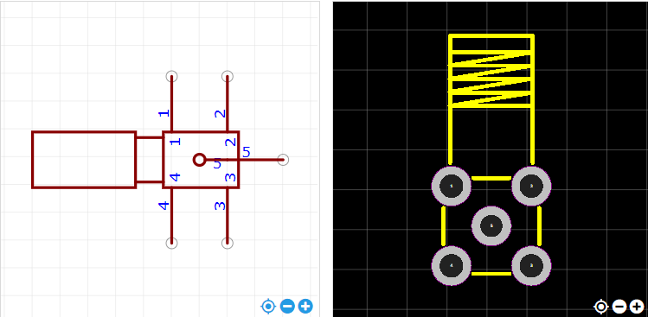
https://item.szlcsc.com/985455.html

